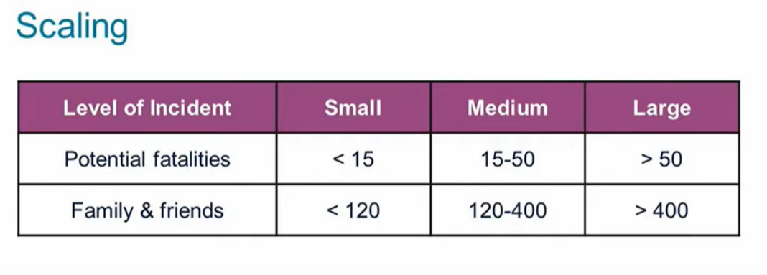

**Small-scale response**: Typically involves incidents with a limited number of victims that can be managed by local jurisdiction resources without significant external assistance. This may include incidents less than 15 casualties, where local emergency services can effectively provide medical care and support to the affected individuals.

* JFSOC
* Registration
* Family Briefing Area & Feeding
* Childcare
* Transportation
* Private Rooms
* Security

|  |  |  |  |  |
| --- | --- | --- | --- | --- |
| **Name** | **Facility Address** | **Potential Locations** | **Point of Contact (POC) Name, Phone Number, and Email** | **MOU Dates** |
|  |  | EX: Gym, Amphitheater, Community Center |  |  |
|  |  |  |  |  |
|  |  |  |  |  |

**Medium-scale response**: Involves incidents with a larger number of victims that exceed the capacity of local resources no manage solely, but can still be managed within the capabilities of regional or mutual aid resources. This may include incidents with 15-50 casualties, where additional support from neighboring jurisdictions or specialized response teams may be required.

* JFSOC
* Registration
* Family Briefing Area
* Feeding Area
* Childcare
* Transportation
* Access to More Private Rooms
* Security
* Responder/Staffing Area
* Forensic Command Center

|  |  |  |  |  |
| --- | --- | --- | --- | --- |
| **Name** | **Facility Address** | **Potential Locations** | **Point of Contact (POC) Name, Phone Number, and Email** | **MOU Dates** |
|  |  | EX: Conf Room, Banquet Hall |  |  |
|  |  |  |  |  |
|  |  |  |  |  |

**Large-scale response**: Involves incidents with a significant number of victims that overwhelm local, regional, or mutual aid resources, requiring a coordinated response involving state, federal, and/or international assistance. This may include incidents with more than 50 casualties, where specialized resources, such as mass casualty incident teams, medical evacuation assets, and disaster response agencies, are mobilized to provide support and assistance.

* JFSOC
* Increased Staffing for Client Registration
* Volunteer/Staff Registration
* Large Family Briefing Area
* Childcare
* Transportation
* Extensive Access to Private Rooms
* Security
* Feeding Area
* Responder/Staffing Area
* Forensic Command Center

|  |  |  |  |  |
| --- | --- | --- | --- | --- |
| **Name** | **Facility Address** | **Potential Locations** | **Point of Contact (POC) Name, Phone Number, and Email** | **MOU Dates** |
|  |  | EX: Conf Room, Banquet Hall |  |  |
|  |  |  |  |  |
|  |  |  |  |  |

